**Snapshot #1**

Snapshot #2

**Snapshot #3**

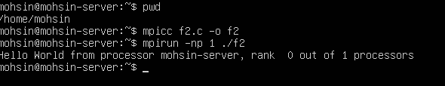

**Linux Commands**

